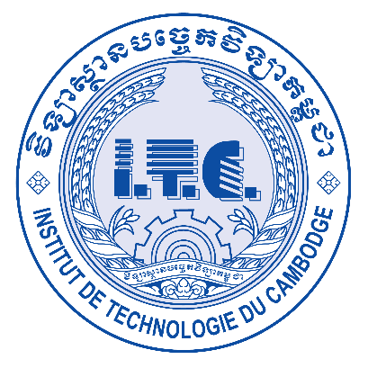 ព្រះរាជាណាចក្រកម្ពុជា

ជាតិ​ ​ សាសនា ព្រះមហាក្សត្រ

**Institute of technology of Cambodia**

**Department of Information and communication**

<<Report TP IP04>>

*TP: INTERNET PROGRAM*

*Lecturer: HOK TIN*

*Student: VEN THON*

*ID: e20191250*

*Group: I4-GIC-C*

*Year: 2023-2024*

Contents

Ex1: Tab design following UI to have 3 tabs 3

Ex2: Responsive menu design following responsive UI as following 8

Ex3: Counter build a number counter app with Class/Object concept and local storage 12

Ex4: Random color generator build a color generator app with Class/Object concept with local storage. 15

Ex5: Responsive Navigation Bar build a navigation bar to support both wide and mobile screen 18

Ex6: Side Bar Build an app with a slide bar 22

# Ex1: Tab design following UI to have 3 tabs

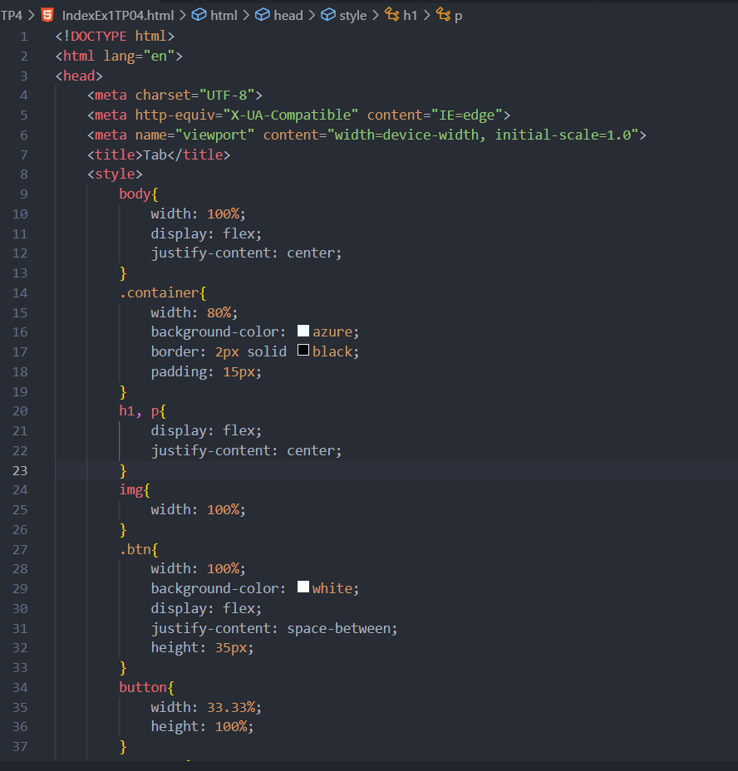

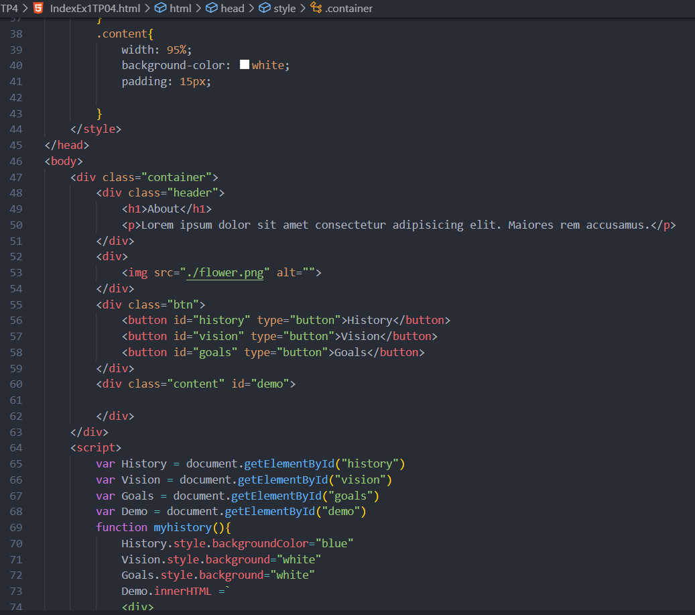

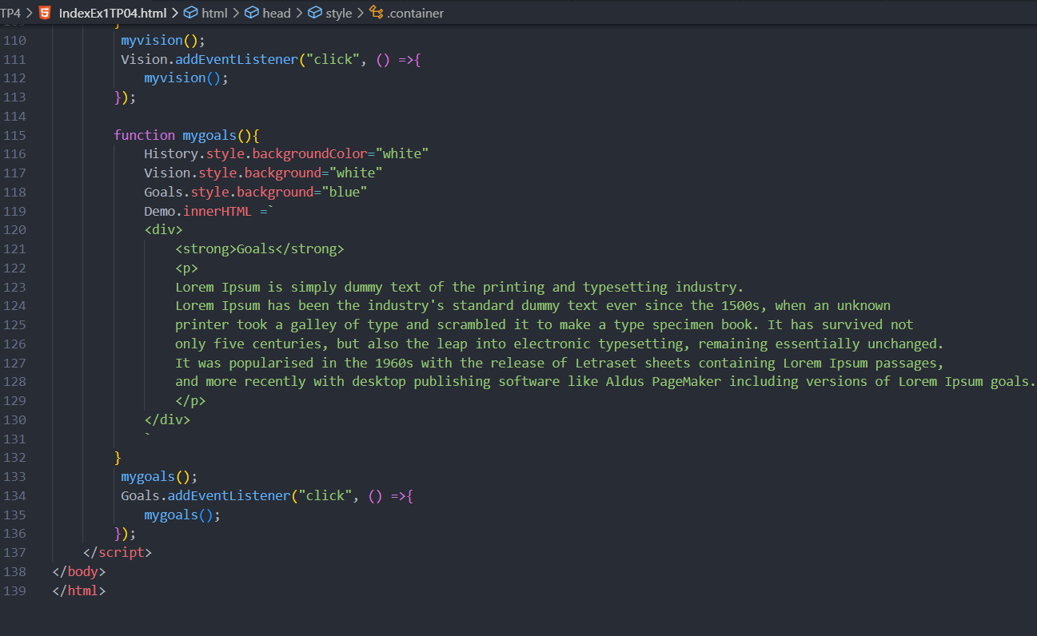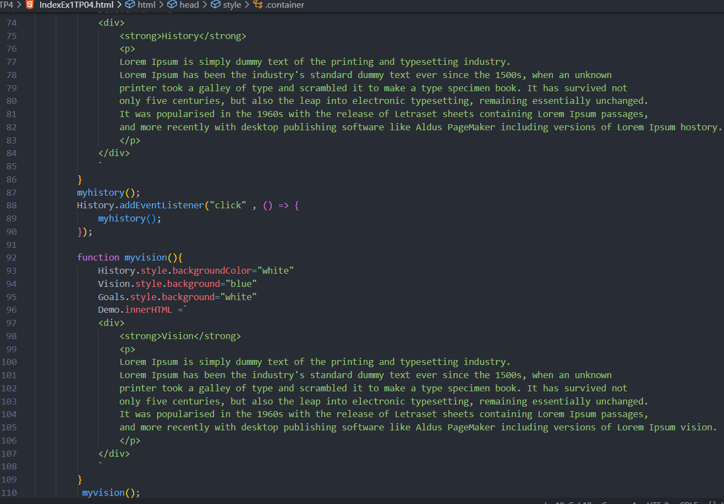

Output:

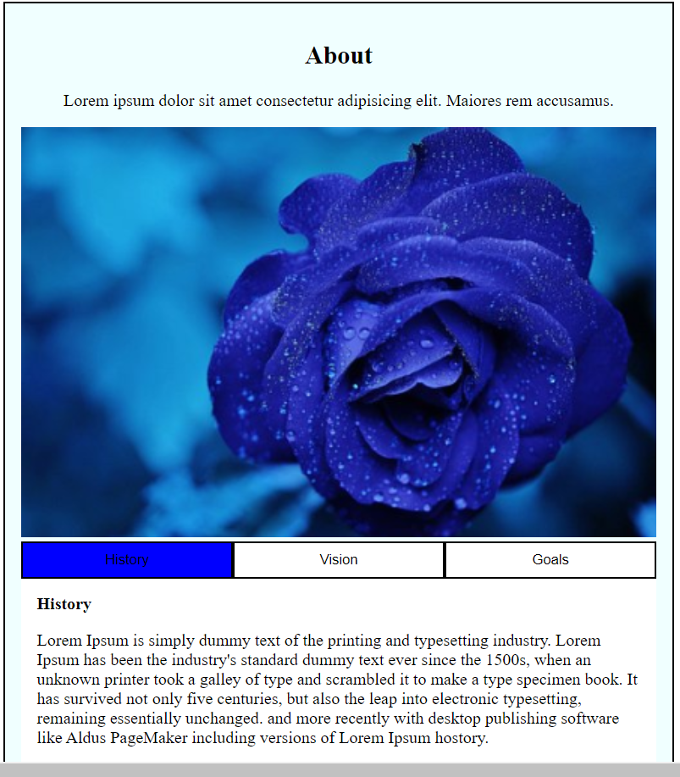

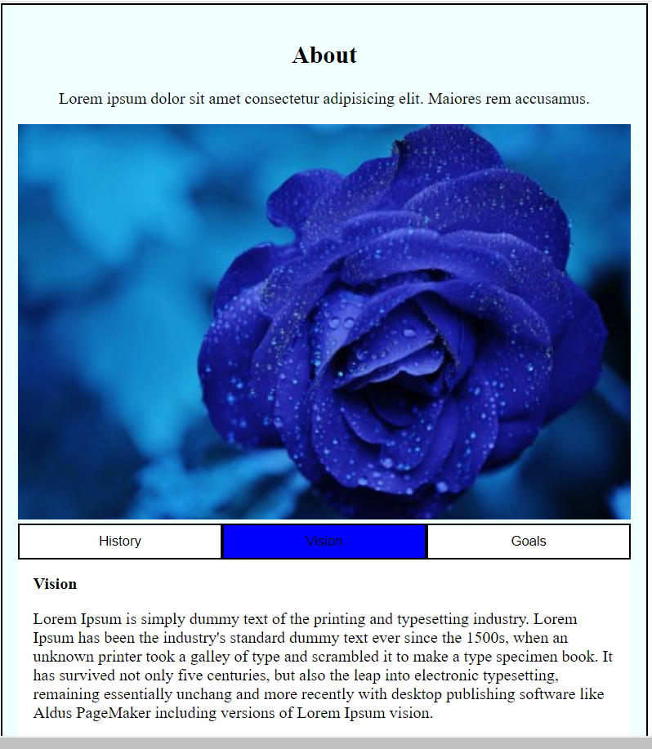

# Ex2: Responsive menu design following responsive UI as following

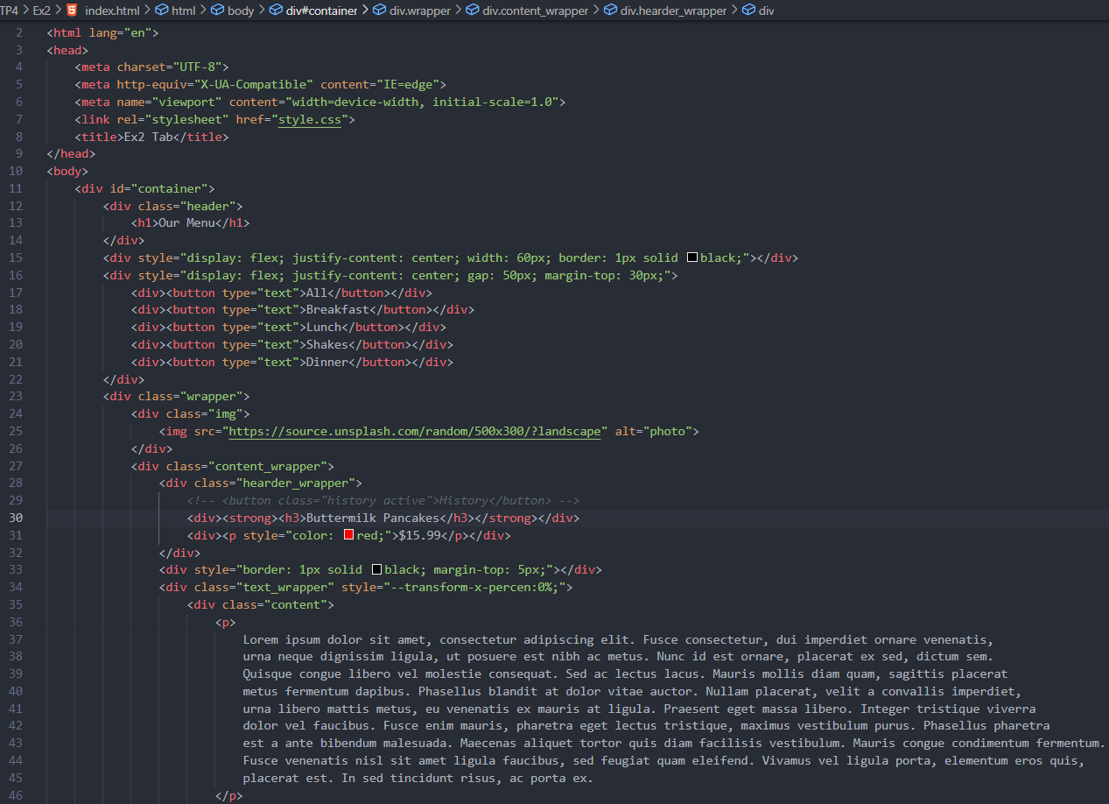

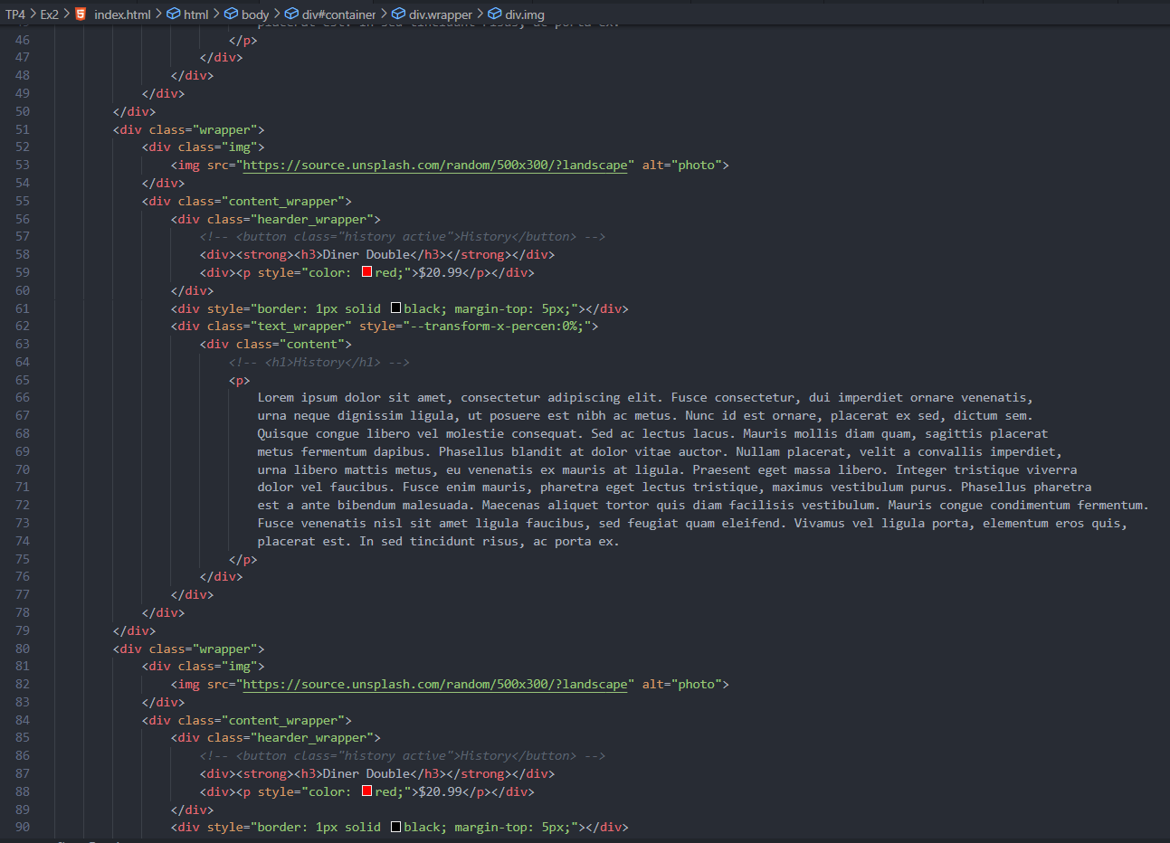

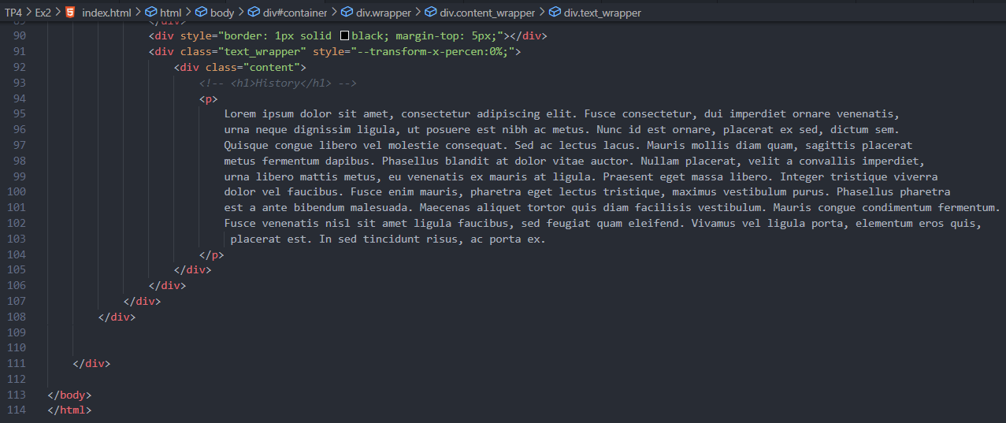

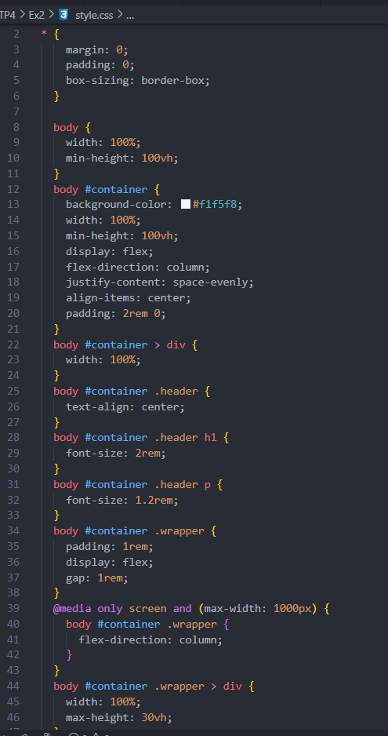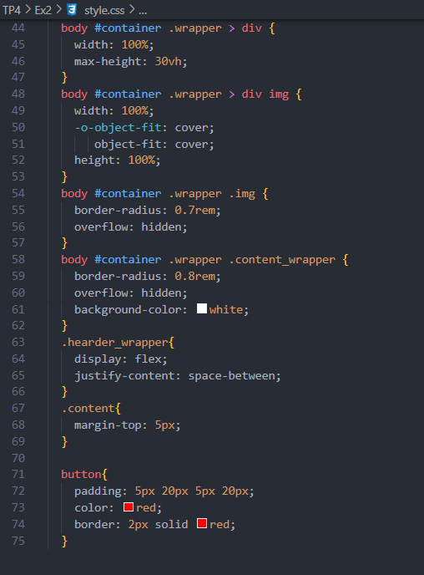

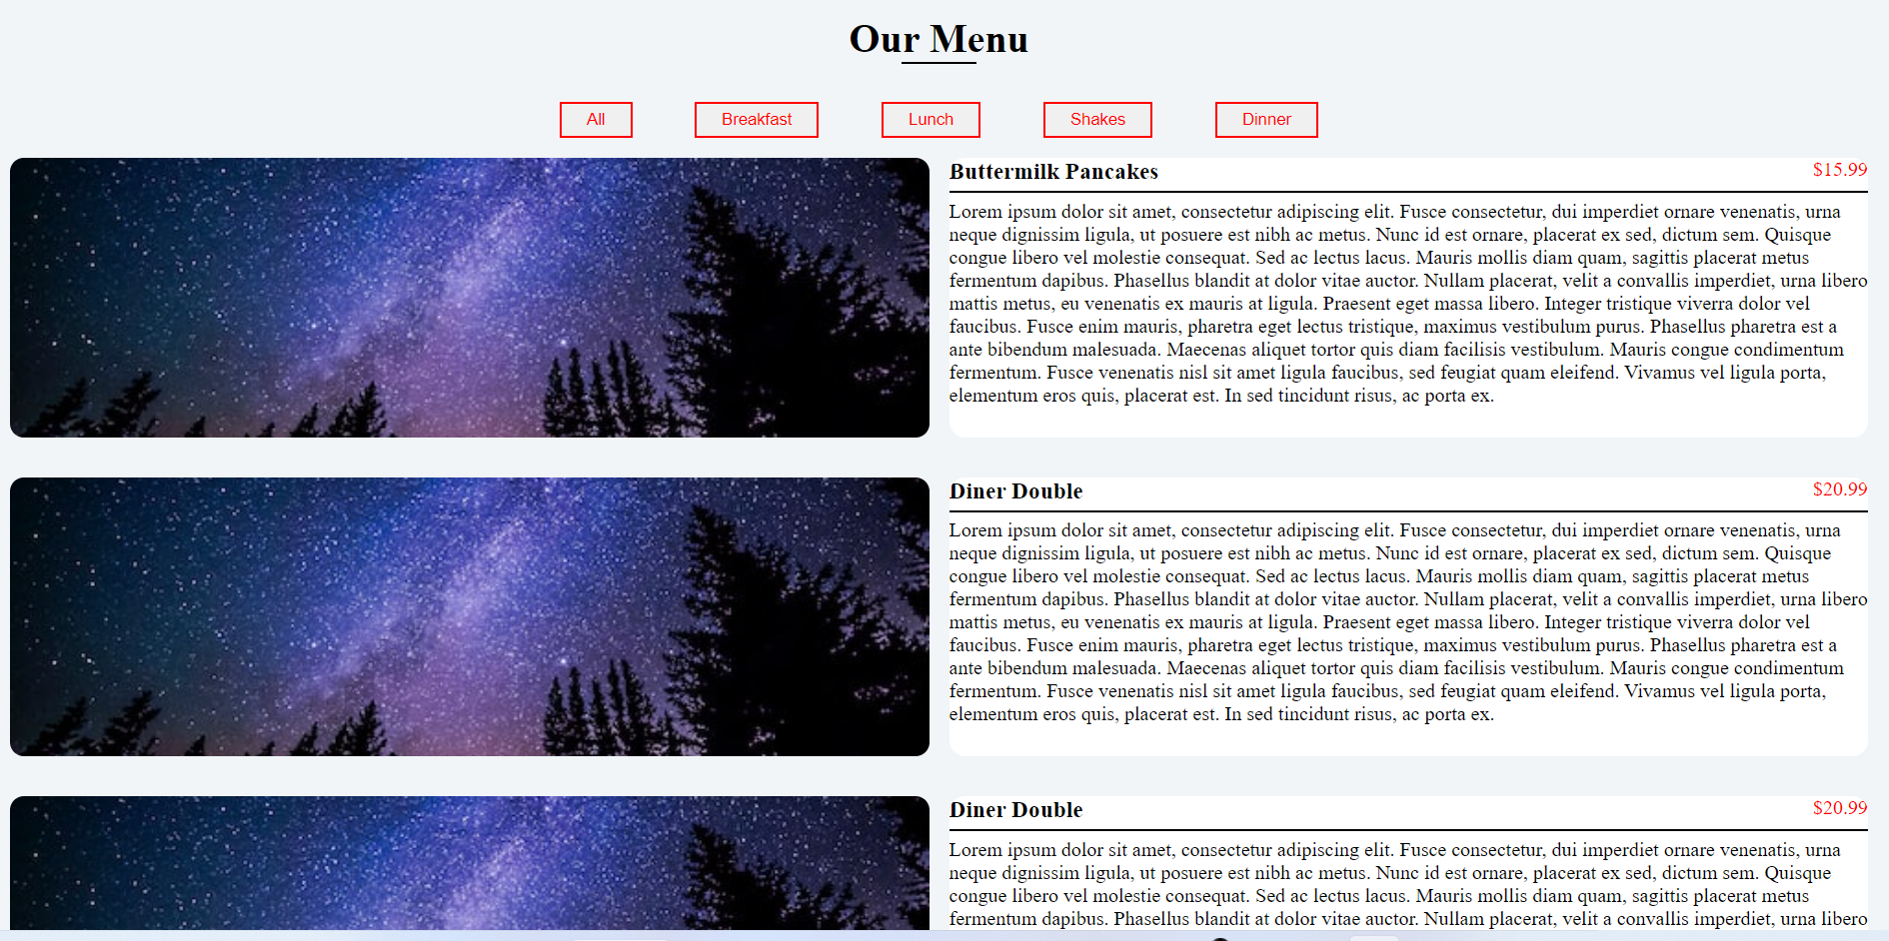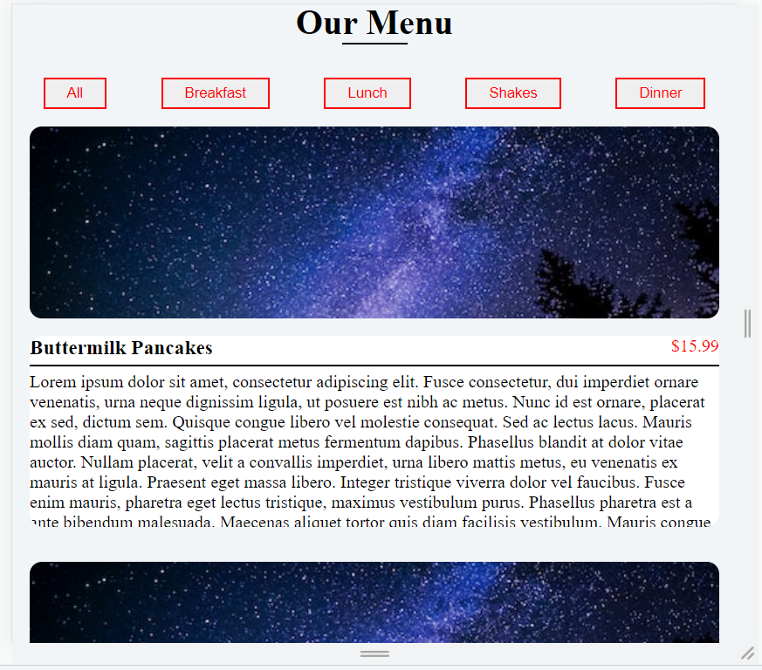Output:

# Ex3: Counter build a number counter app with Class/Object concept and local storage

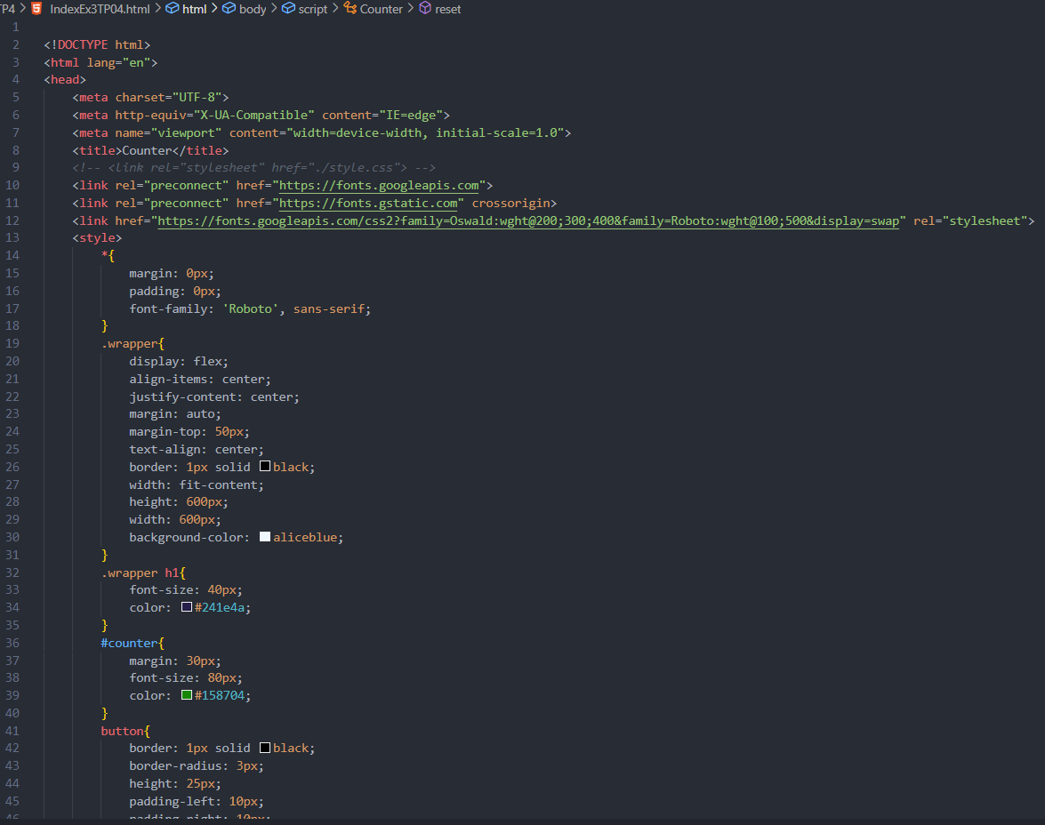

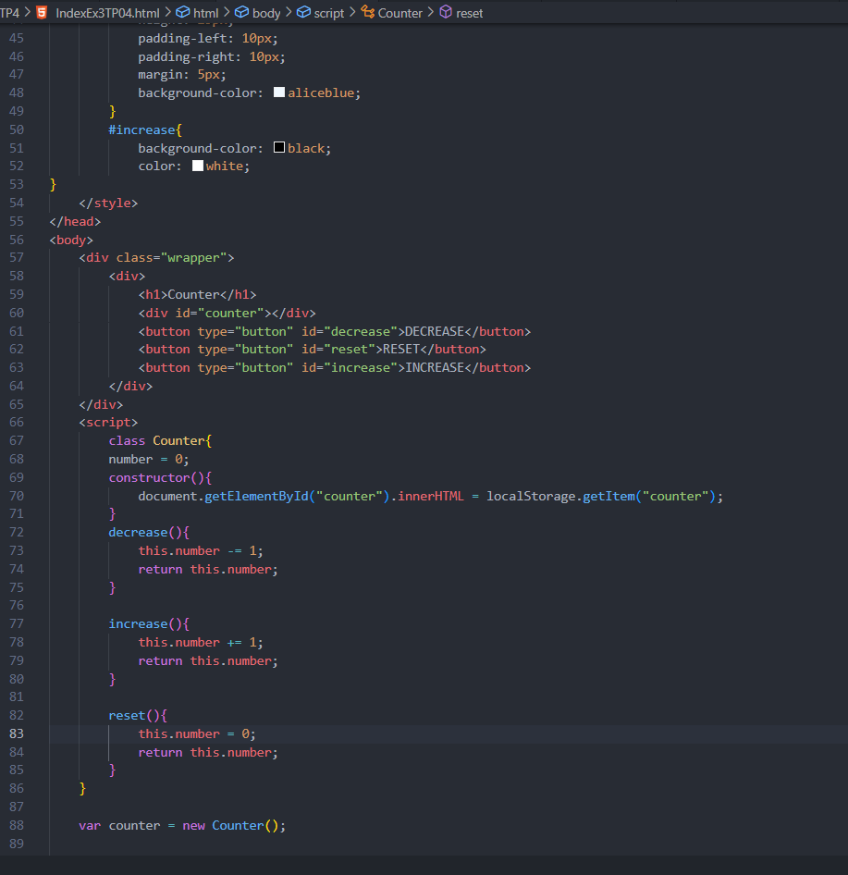

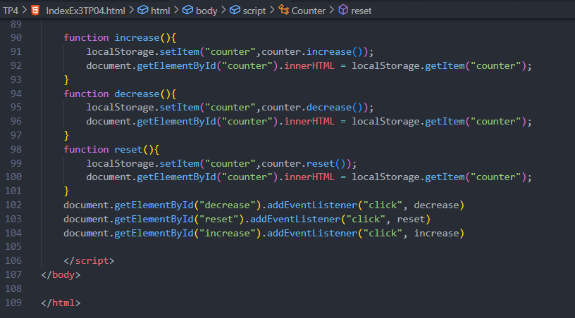

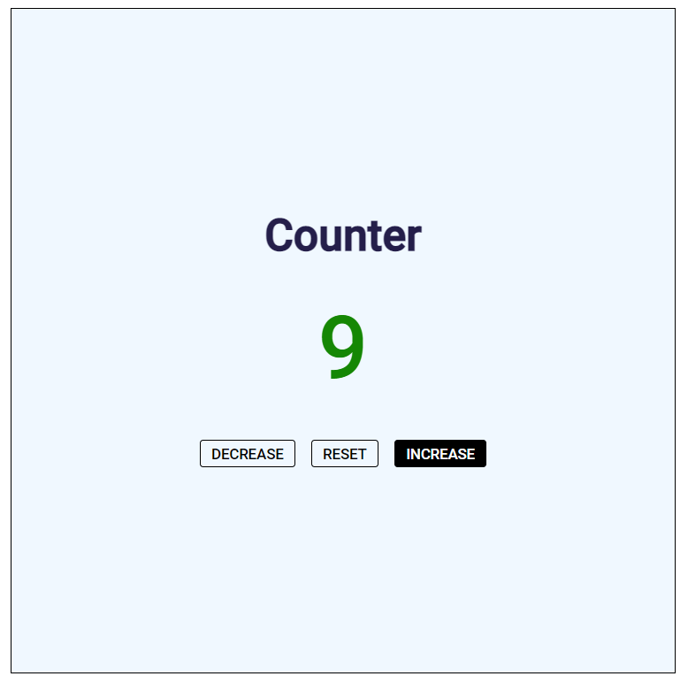Output:

# Ex4: Random color generator build a color generator app with Class/Object concept with local storage.

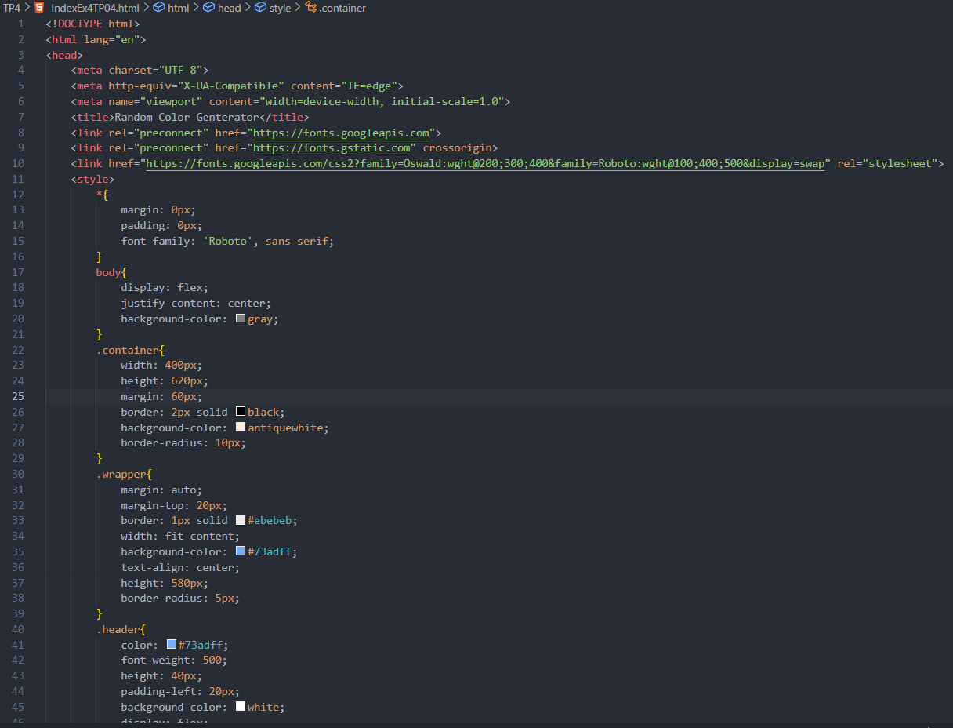

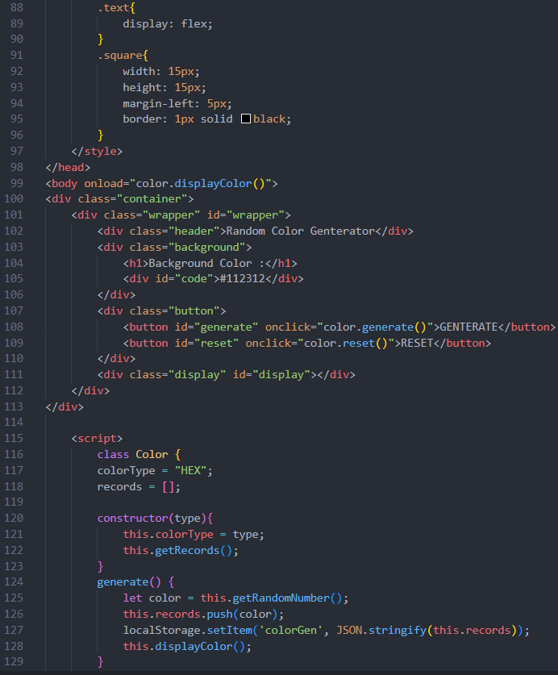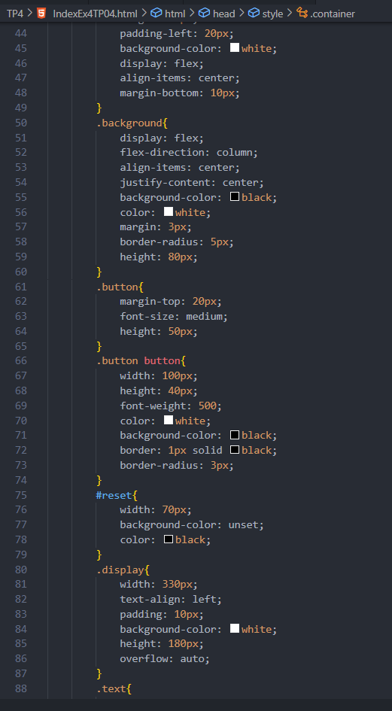

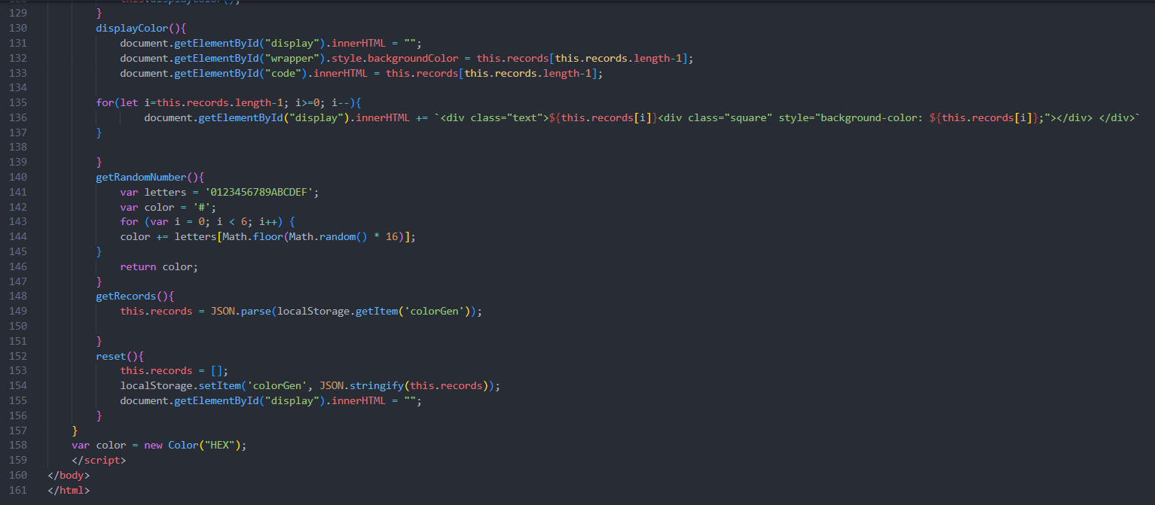

Output:

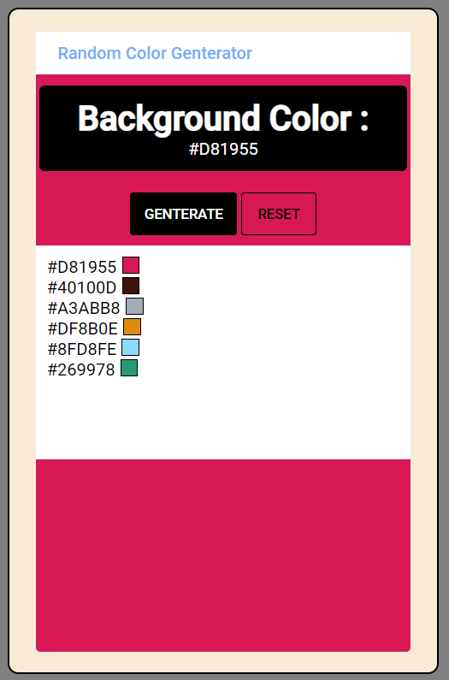

# Ex5: Responsive Navigation Bar build a navigation bar to support both wide and mobile screen

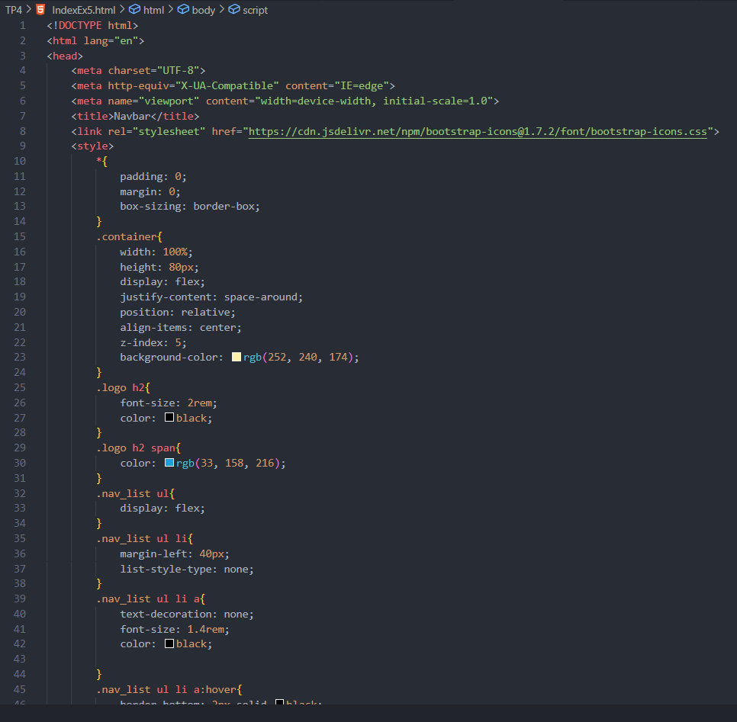

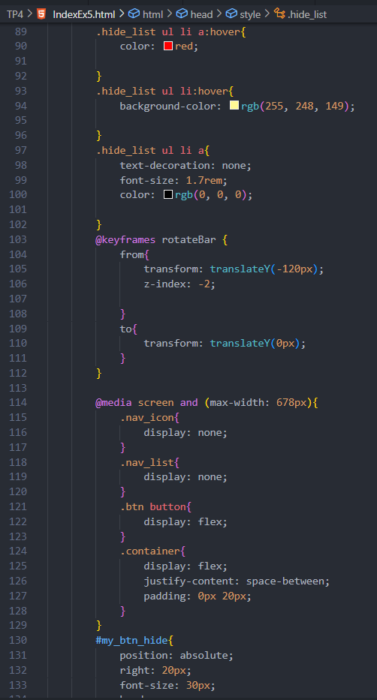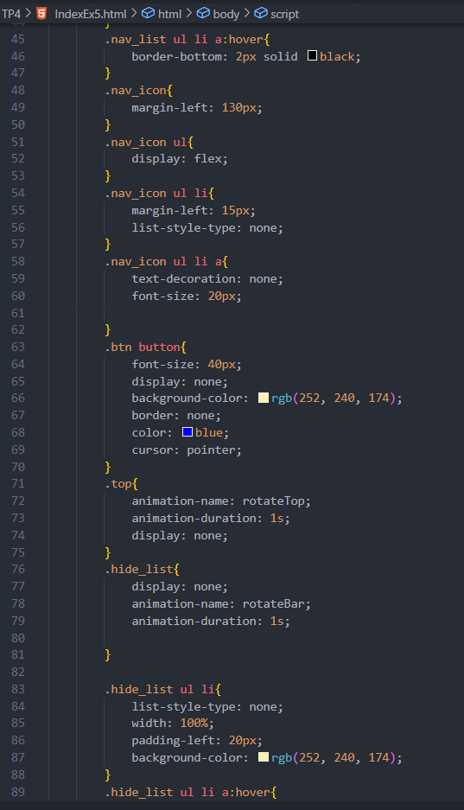

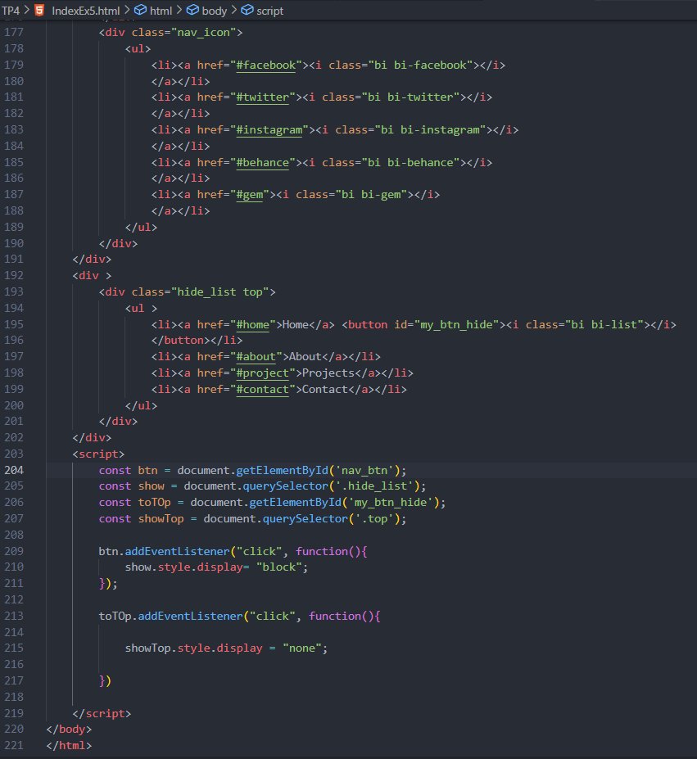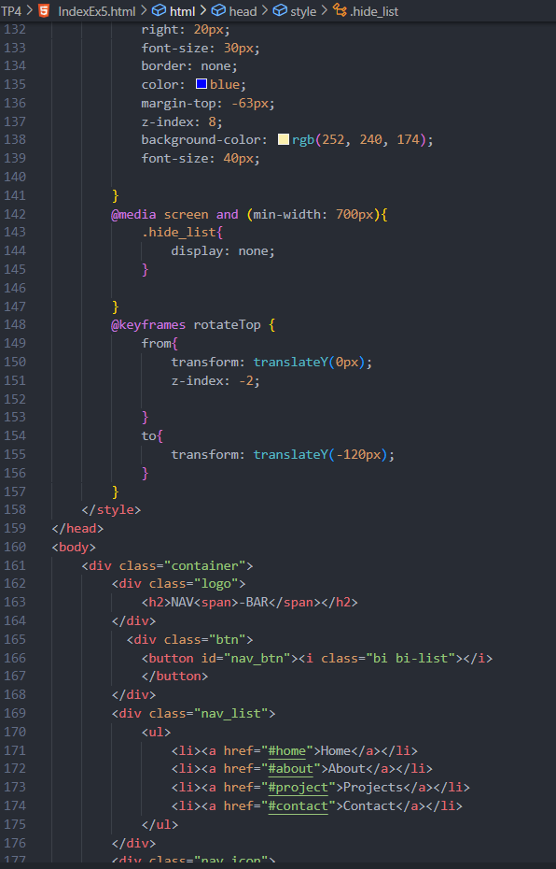a

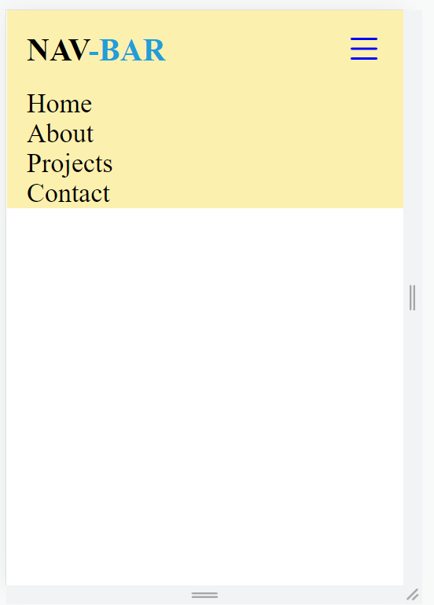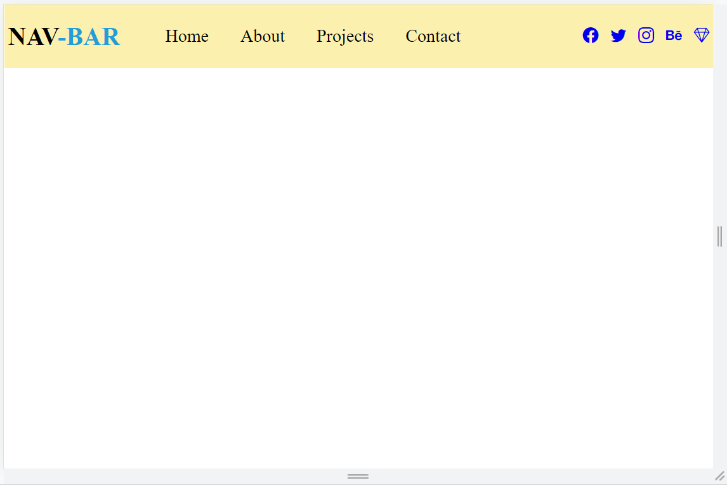

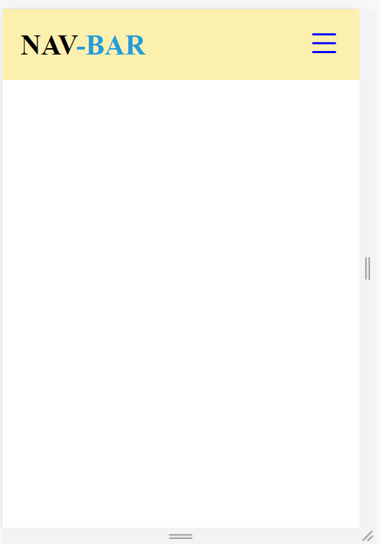

# Ex6: Side Bar Build an app with a slide bar

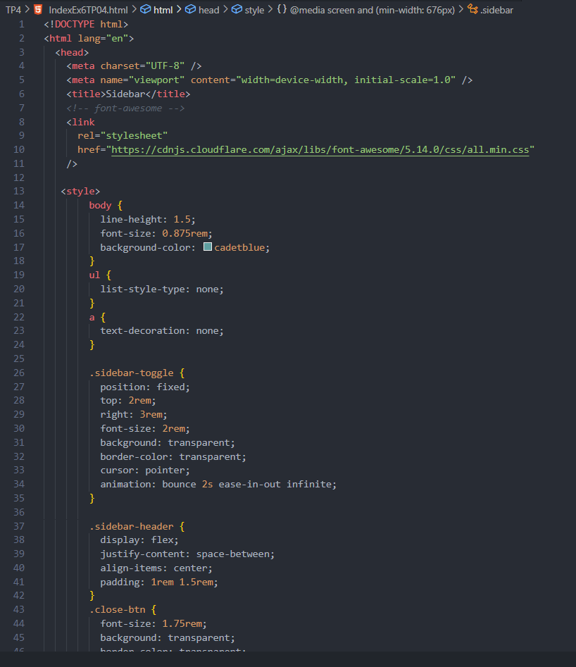

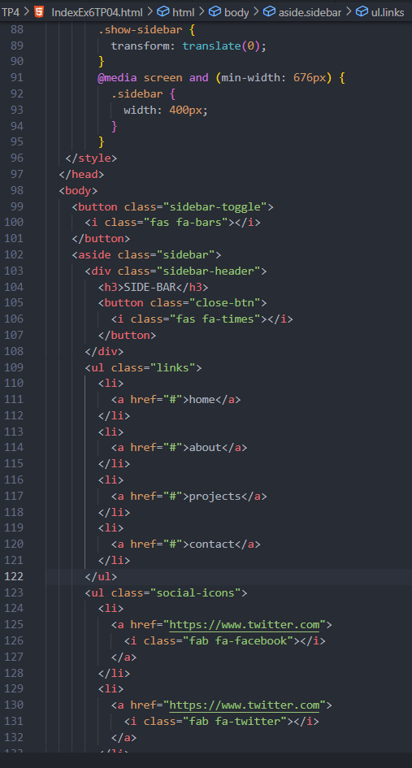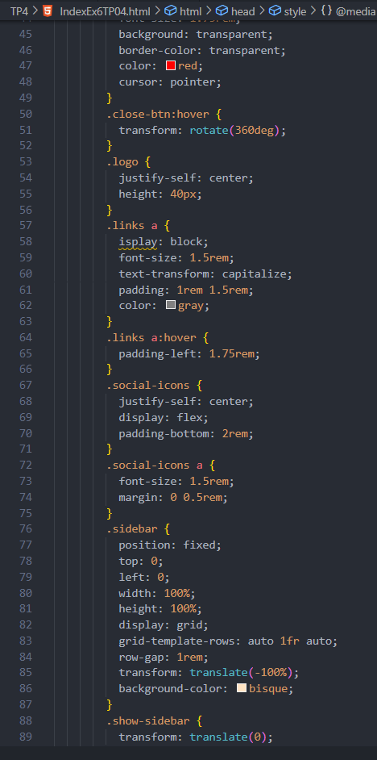

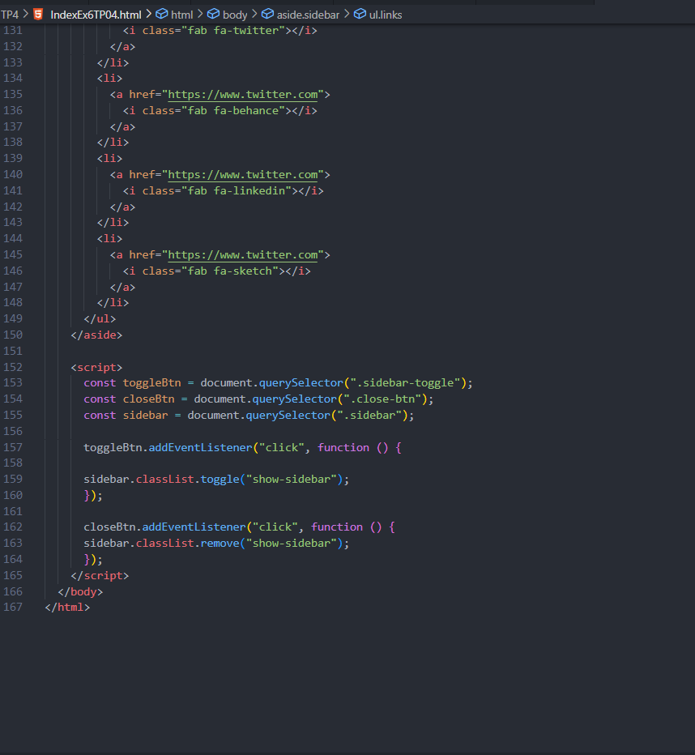

Output:

